**Household Support Fund 25/26**

**Dear Parent/Carer,**

We understand that buying school uniforms can be difficult, especially when money is tight. We want to help make things a little easier for you and your family.

If you meet the criteria below, you may be able to get help through the **Household Support Fund**.

This support includes vouchers that can be used at **Rummage Rescuers**, **Thomas Street, BB2 1NR**, to get **new or pre-loved (second-hand) school uniform items.**

You can drop in to any of the Family Hubs listed below to receive a voucher:

Family Hub Darwen  
Lord Street  
BB3 0HD  
United Kingdom

Family Hub Little Harwood  
Robinson Street  
BB1 5PE  
United Kingdom

Family Hub Livesey  
Andrew Close  
BB2 4NU  
United Kingdom

Family Hub Shadsworth  
Shadsworth Road  
BB1 2HR  
United Kingdom

Please ask a member of staff at the Family Hub – we’re here to support you.

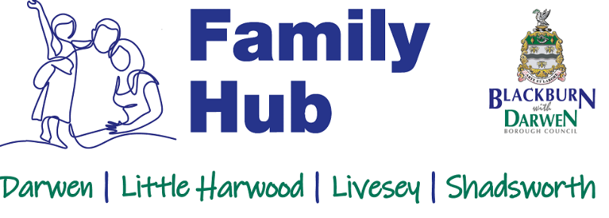

**Household Support Fund – Who Can Get Help?**

You may be eligible if:

**You are working and your household income is:**

* Less than **£26,057** a year (before tax and National Insurance) if you're a **single adult**
* Less than **£38,870** a year (before tax and National Insurance) if you are **two or more adults** in work
* And your **household savings are below £2,000**

**OR you receive income-based benefits and meet any of these conditions:**

* You have a **physical or learning disability**, or **Autism**
* You have a **long-term health condition** that is made worse by cold weather
* You rely on **electrical equipment** to live independently
* You have **vulnerable adults or children** in your home who are supported by **mental health services**, **social workers**, or **family support**
* You are a **carer**
* You are a **refugee or asylum seeker**
* You have **recently started or left a job** and are waiting for benefits to start
* Your **Universal Credit payment is £0** due to a changeable or part-time income

You may also be able to apply online for more help from the Household Support Fund:  
👉 [**Household Support Fund | Blackburn with Darwen Borough Council**](https://www.blackburn.gov.uk/)

If you don’t qualify for the Household Support Fund, there are **other types of help available too**. Please ask your school what support they offer.

**There will be a Uniform Pop-Up Shop at Thomas Street for all parents on 9th August between 10am and 2pm.**